CPE301 – SPRING 2019

MIDTERM 2

Student Name: Clayton Higbee

Student #: 5001189864

Student Email: higbee@unlv.nevada.edu

Primary Github address: <https://github.com/claytonjhigbee/CODSWORTH_MAIN>

Directory:

1. **COMPONENTS LIST AND CONNECTION BLOCK DIAGRAM w/ PINS**

List of Components used

Atmega328PB

ESP-01

APDS 9960

Atmega328PB – ESP-01

Tx – Rx

Rx – Tx

3.3V – Vin

Atmega328PB – APDS 9960

SCL – SCL

SDA – SDA

5V - Vin

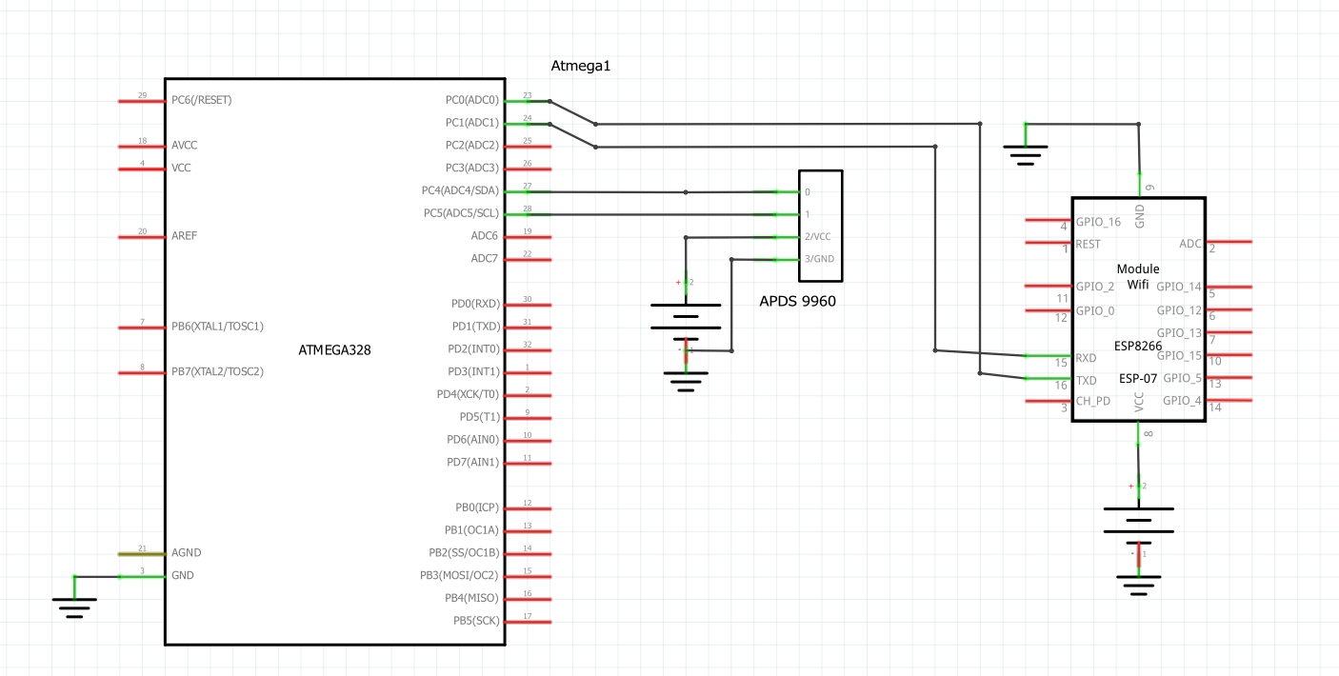

1. **INITIAL/MODIFIED/DEVELOPED CODE OF TASK 1/A**

/*

APDSESPSerialWrite.c

Created: 5/11/2019 3:37:39 PM

Author : higbee

*/

#define F_CPU 16000000UL

#include <avr/io.h>

#include <util/delay.h>

#include <stdio.h>

#include "i2c_master.h"

#include "uart.h"

#include "apds.h"

#define BAUD 9600

#define BAUD_PRESCALLER F_CPU/16/BAUD-1 // Baud rate prescaller

#define BRGVAL (F_CPU/16/BAUD) - 1

#ifndef APDS_H

#define APDS_H

#include <avr/io.h>

#include "i2c_master.h"

#include "apds.h"

#define APDS_WRITE (0x39 << 1) | 0

#define APDS_READ (0x39 << 1) | 1

/* APDS-9960 I2C address */

#define APDS9960_I2C_ADDR 0x39

/* Error code for returned values */

#define ERROR 0xFF

/* Acceptable device IDs */

#define APDS9960_ID_1 0xAB

#define APDS9960_ID_2 0x9C

/* Misc parameters */

#define FIFO_PAUSE_TIME 30 // Wait period (ms) between FIFO reads

/* APDS-9960 register addresses */

#define APDS9960_ENABLE 0x80

#define APDS9960_ATIME 0x81

#define APDS9960_WTIME 0x83

#define APDS9960_PERS 0x8C

#define APDS9960_CONFIG1 0x8D

#define APDS9960_PPULSE 0x8E

#define APDS9960_CONFIG2 0x90

#define APDS9960_ID 0x92

#define APDS9960_WDATAL 0x94

#define APDS9960_WDATAH 0x95

#define APDS9960_RDATAL 0x96

#define APDS9960_RDATAH 0x97

#define APDS9960_GDATAL 0x98

#define APDS9960_GDATAH 0x99

#define APDS9960_BDATAL 0x9A

#define APDS9960_BDATAH 0x9B

#define APDS9960_POFFSET_UR 0x9D

#define APDS9960_POFFSET_DL 0x9E

#define APDS9960_CONFIG3 0x9F

/* Bit fields */

#define APDS9960_PON 0b00000001

#define APDS9960_AEN 0b00000010

#define APDS9960_PEN 0b00000100

#define APDS9960_WEN 0b00001000

#define APSD9960_AIEN 0b00010000

#define APDS9960_PIEN 0b00100000

#define APDS9960_GEN 0b01000000

#define APDS9960_GVALID 0b00000001

/* On/Off definitions */

#define OFF 0

#define ON 1

/* Acceptable parameters for setMode */

#define POWER 0

#define AMBIENT_LIGHT 1

/*#define PROXIMITY 2*/

#define WAIT 3

#define AMBIENT_LIGHT_INT 4

#define ALL 7

/* LED Drive values */

#define LED_DRIVE_100MA 0

#define LED_DRIVE_50MA 1

#define LED_DRIVE_25MA 2

#define LED_DRIVE_12_5MA 3

/* LED Boost values */

#define LED_BOOST_100 0

#define LED_BOOST_150 1

#define LED_BOOST_200 2

#define LED_BOOST_300 3

/* Default values */

#define DEFAULT_ATIME 219 // 103ms

#define DEFAULT_WTIME 246 // 27ms

#define DEFAULT_PROX_PPULSE 0x87 // 16us, 8 pulses

#define DEFAULT_POFFSET_UR 0 // 0 offset

#define DEFAULT_POFFSET_DL 0 // 0 offset

#define DEFAULT_CONFIG1 0x60 // No 12x wait (WTIME) factor

#define DEFAULT_LDRIVE LED_DRIVE_100MA

#define DEFAULT_PGAIN PGAIN_4X

#define DEFAULT_AGAIN AGAIN_4X

#define DEFAULT_AILT 0xFFFF // Force interrupt for calibration

#define DEFAULT_AIHT 0

#define DEFAULT_PERS 0x11 // 2 consecutive prox or ALS for int.

#define DEFAULT_CONFIG2 0x01 // No saturation interrupts or LED boost

#define DEFAULT_CONFIG3 0 // Enable all photodiodes, no SAI

#define DEFAULT_GLDRIVE LED_DRIVE_100MA

#define DEFAULT_GWTIME GWTIME_2_8MS

void apds_init();

void readColor();

#endif

*FILE* str_uart = *FDEV_SETUP_STREAM*(uart_putchar, *NULL* , *_FDEV_SETUP_WRITE*);

char results[256];

char outs[256]; // String array used for sending USART commands

volatile char received_data; // String array used for receiving USART communication

void init_UART();

int uart_putchar( char c, *FILE* *stream);

void USART_init( unsigned int ubrr ); // Initialize USART communication

void USART_tx_string(char *data); //Print String USART

int main(void){

*uint16_t* red = 0, green = 0, blue = 0, white = 0;

i2c_init();

USART_init(BAUD_PRESCALLER); // Initialize the USART (RS232 interface)

*_delay_ms*(500); // Delay to allow hardware to initialize

*stdout* = &str_uart;

apds_init();

while (1) {

/* Initialize AT commands */

//AT connect check

unsigned char AT[] = "AT\r\n";

//Set device mode, 1 = Station mode

unsigned char AT_CWMODE[] = "AT+CWMODE=1\r\n";

//Perform Wifi connection, provide SSID and Password

unsigned char AT_CWJAP[] = "AT+CWJAP=\"Higbee_Pixel\",\"Higbee19\"\r\n";

//Set device for single IP Address Mode

unsigned char AT_CIPMUX[] = "AT+CIPMUX=0\r\n";

// Start TCP connection to Thingspeak.com at port 80

unsigned char AT_CIPSTART[] = "AT+CIPSTART=\"TCP\",\"api.thingspeak.com\",80\r\n";

// Give upcoming string length

unsigned char AT_CIPSEND[] = "AT+CIPSEND=130\r\n";

// Send commands listed from above

*_delay_ms*(200);

USART_tx_string(AT);

*_delay_ms*(5000);

USART_tx_string(AT_CWMODE);

*_delay_ms*(5000);

USART_tx_string(AT_CWJAP);

*_delay_ms*(15000);

USART_tx_string(AT_CIPMUX);

*_delay_ms*(10000);

USART_tx_string(AT_CIPSTART);

*_delay_ms*(10000);

USART_tx_string(AT_CIPSEND);

*_delay_ms*(5000);

// Read the next colors

readColor(&red, &green, &blue, &white);

// Print Data to Thingspeak using provided link, website channel key, and field location

// Send Red

*snprintf*(outs,sizeof(outs),"GET https://api.thingspeak.com/update?api_key=IKAXX2LP9LJMS0IU&field1=%3d\r\n", red);

USART_tx_string(outs);//send data

*_delay_ms*(15000);

// Send Green

USART_tx_string(AT_CIPMUX);

*_delay_ms*(10000);

USART_tx_string(AT_CIPSTART);

*_delay_ms*(10000);

USART_tx_string(AT_CIPSEND);

*_delay_ms*(5000);

*snprintf*(outs,sizeof(outs),"GET https://api.thingspeak.com/update?api_key=IKAXX2LP9LJMS0IU&field2=%3d\r\n", green);

USART_tx_string(outs);//send data

*_delay_ms*(15000);

// Send Green

USART_tx_string(AT_CIPMUX);

*_delay_ms*(10000);

USART_tx_string(AT_CIPSTART);

*_delay_ms*(10000);

USART_tx_string(AT_CIPSEND);

*_delay_ms*(5000);

*snprintf*(outs,sizeof(outs),"GET https://api.thingspeak.com/update?api_key=IKAXX2LP9LJMS0IU&field3=%3d\r\n", blue);

USART_tx_string(outs);//send data

*_delay_ms*(15000);

// Send White

USART_tx_string(AT_CIPMUX);

*_delay_ms*(10000);

USART_tx_string(AT_CIPSTART);

*_delay_ms*(10000);

USART_tx_string(AT_CIPSEND);

*_delay_ms*(5000);

*snprintf*(outs,sizeof(outs),"GET https://api.thingspeak.com/update?api_key=IKAXX2LP9LJMS0IU&field4=%3d\r\n", white);

USART_tx_string(outs);//send data

*_delay_ms*(15000);

}

}

void apds_init(){

*uint8_t* setup;

i2c_readReg(APDS_WRITE, APDS9960_ID, &setup,1);

if(setup != APDS9960_ID_1) while(1);

setup = 1 << 1 | 1<<0 | 1<<3 | 1<<4;

i2c_writeReg(APDS_WRITE, APDS9960_ENABLE, &setup, 1);

setup = DEFAULT_ATIME;

i2c_writeReg(APDS_WRITE, APDS9960_ATIME, &setup, 1);

setup = DEFAULT_WTIME;

i2c_writeReg(APDS_WRITE, APDS9960_WTIME, &setup, 1);

setup = DEFAULT_PROX_PPULSE;

i2c_writeReg(APDS_WRITE, APDS9960_PPULSE, &setup, 1);

setup = DEFAULT_POFFSET_UR;

i2c_writeReg(APDS_WRITE, APDS9960_POFFSET_UR, &setup, 1);

setup = DEFAULT_POFFSET_DL;

i2c_writeReg(APDS_WRITE, APDS9960_POFFSET_DL, &setup, 1);

setup = DEFAULT_CONFIG1;

i2c_writeReg(APDS_WRITE, APDS9960_CONFIG1, &setup, 1);

setup = DEFAULT_PERS;

i2c_writeReg(APDS_WRITE, APDS9960_PERS, &setup, 1);

setup = DEFAULT_CONFIG2;

i2c_writeReg(APDS_WRITE, APDS9960_CONFIG2, &setup, 1);

setup = DEFAULT_CONFIG3;

i2c_writeReg(APDS_WRITE, APDS9960_CONFIG3, &setup, 1);

}

void readColor(*uint16_t* *red, *uint16_t* *green, *uint16_t* *blue, *uint16_t* *white){

*uint8_t* whitel, whiteh;

*uint8_t* redl, redh;

*uint8_t* greenl, greenh;

*uint8_t* bluel, blueh;

i2c_readReg(APDS_WRITE, 0x94, &whitel, 1);

i2c_readReg(APDS_WRITE, 0x95, &whiteh, 1);

i2c_readReg(APDS_WRITE, APDS9960_RDATAL, &redl, 1);

i2c_readReg(APDS_WRITE, APDS9960_RDATAH, &redh, 1);

i2c_readReg(APDS_WRITE, APDS9960_GDATAL, &greenl, 1);

i2c_readReg(APDS_WRITE, APDS9960_GDATAH, &greenh, 1);

i2c_readReg(APDS_WRITE, APDS9960_BDATAL, &bluel, 1);

i2c_readReg(APDS_WRITE, APDS9960_BDATAH, &blueh, 1);

*white = whiteh << 8 | whiteh;

*red = redh << 8 | redl;

*green = greenh << 8 | greenl;

*blue = blueh << 8 | bluel;

}

void init_UART(void){

//Set baud rate

*uint16_t* baud_rate = BRGVAL;

UBRR0H = baud_rate >> 8;

UBRR0L = baud_rate & 0xFF;

//Enable receiver and transmitter

UCSR0B = ( 1 <<RXEN0)|( 1 <<TXEN0);

// Set frame format: 8data, 1stop bit

UCSR0C = (3 <<UCSZ00);

}

int uart_putchar(char c, *FILE* *stream){

//wait until buffer empty

while ( !( UCSR0A & ( 1 <<UDRE0)) );

//Put data into buffer

UDR0 = c;

return 0;

}

/* Initialize USART communication (RS-232) */

void USART_init( unsigned int ubrr ) {

UBRR0H = (unsigned char)(ubrr>>8);

UBRR0L = (unsigned char)ubrr;

UCSR0B |= (1 << TXEN0) | (1 << RXEN0)| ( 1 << RXCIE0); // Enable receiver, transmitter & RX interrupt

UCSR0C |= (1<<UCSZ01) | (1 << UCSZ00);

}

/* USART string sender (RS-232) */

void USART_tx_string( char *data ) {

while ((*data != '\0')) {

while (!(UCSR0A & (1 <<UDRE0)));

UDR0 = *data;

data++;

}

}

1. **SCHEMATICS**



1. **SCREENSHOTS OF EACH TASK OUTPUT (ATMEL STUDIO OUTPUT)**

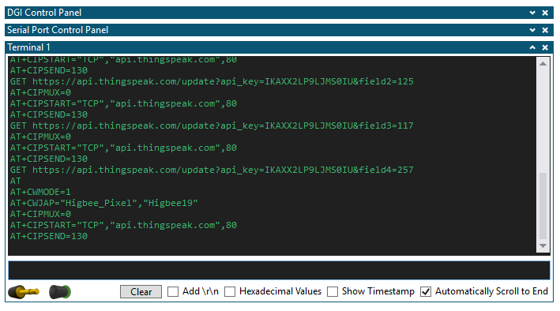

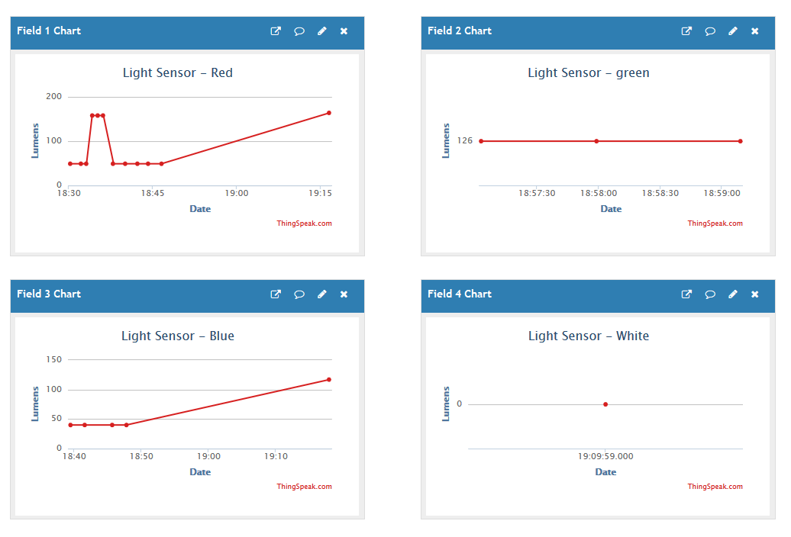

1. **SCREENSHOT OF EACH DEMO (BOARD SETUP)**

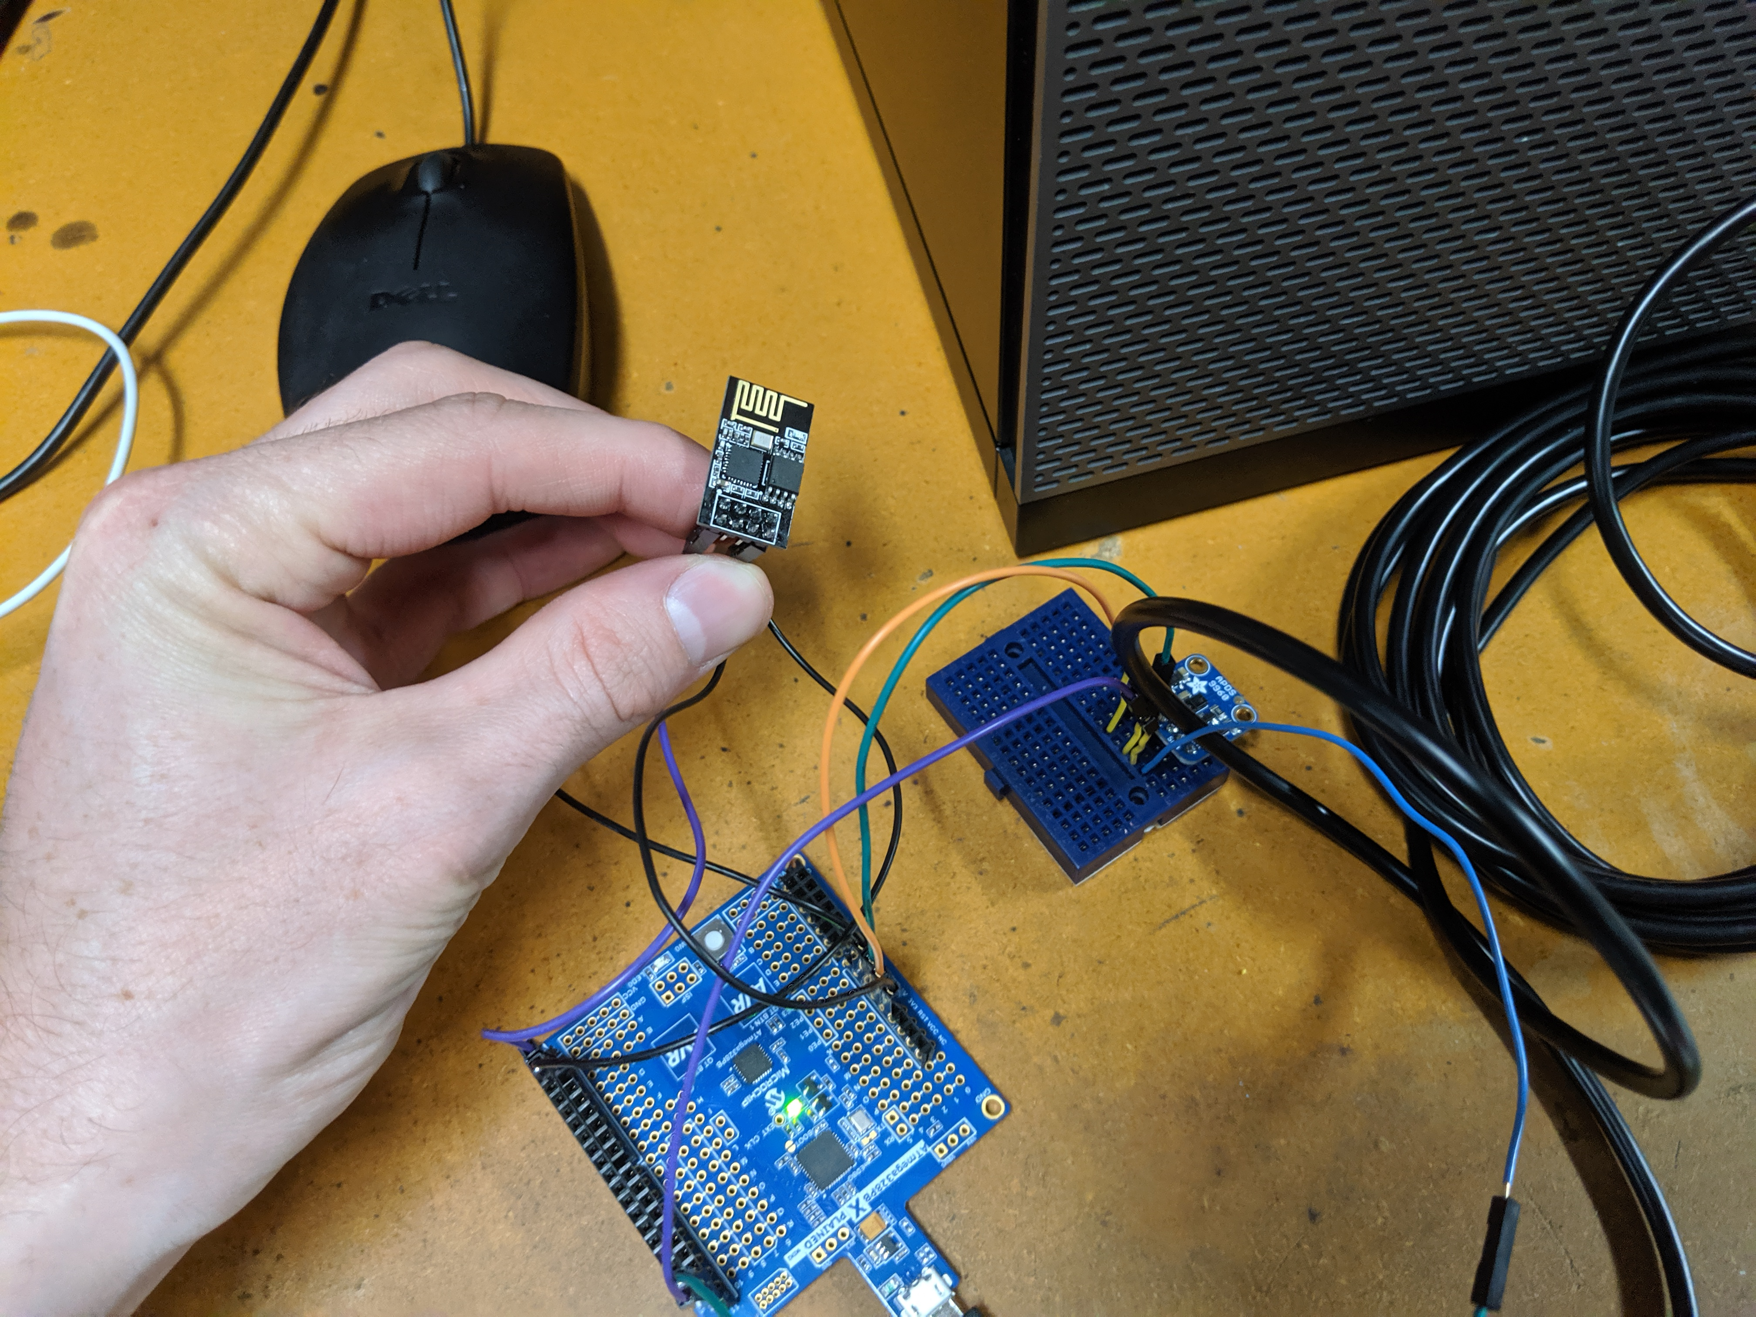

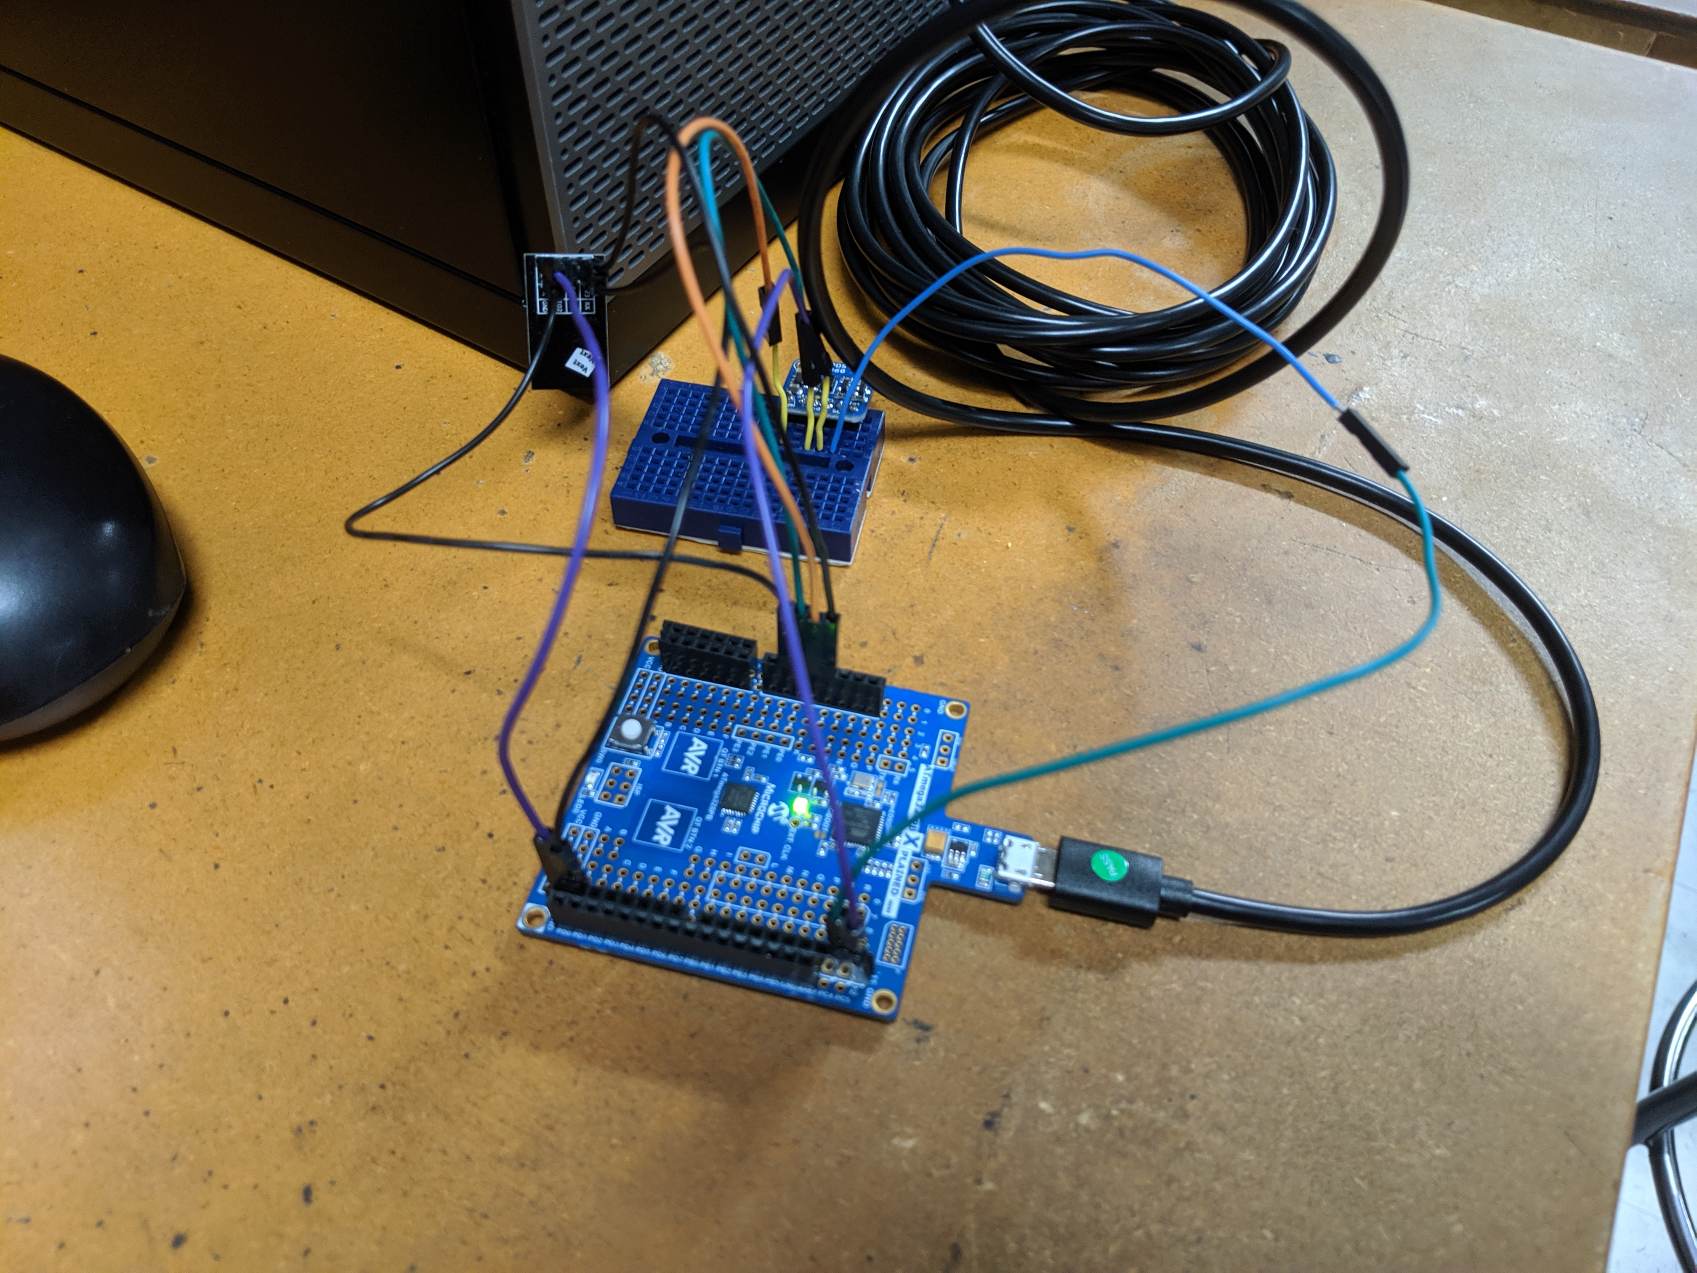

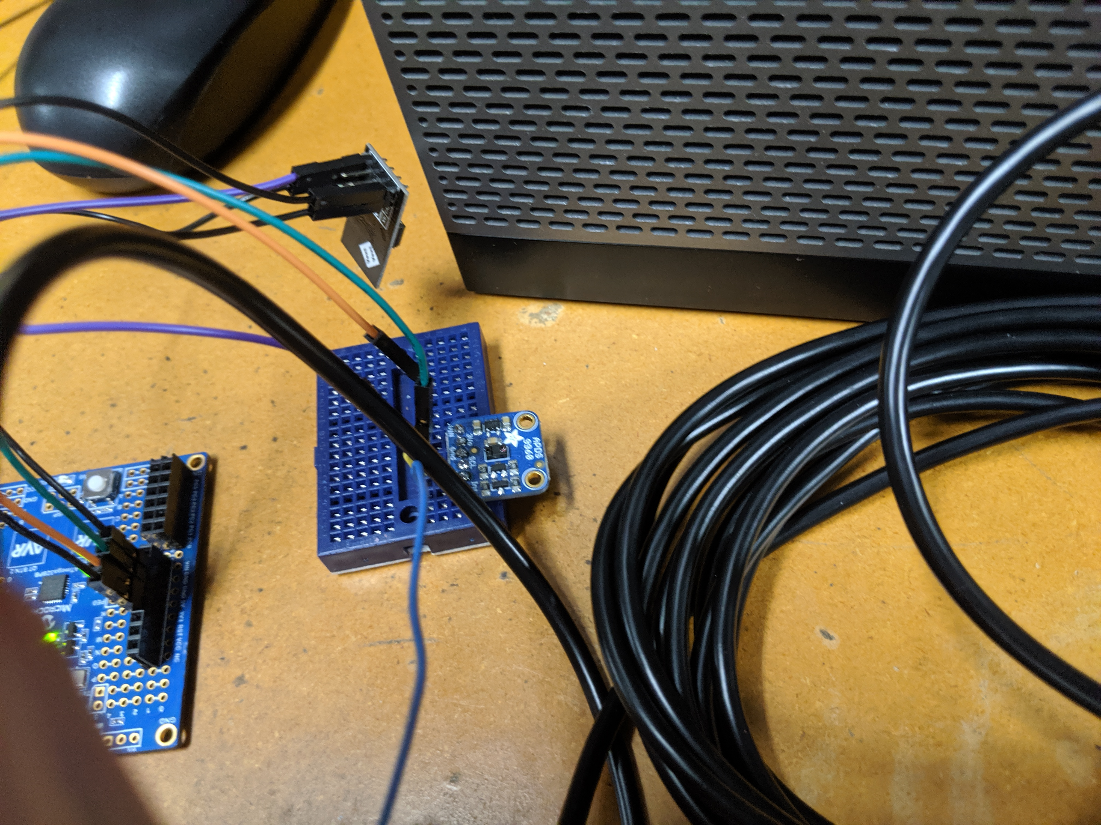

1. **VIDEO LINKS OF EACH DEMO**

<https://youtu.be/mkK5iDd4Gz0>

1. **GITHUB LINK OF THIS DA**

**Student Academic Misconduct Policy**

<http://studentconduct.unlv.edu/misconduct/policy.html>

“This assignment submission is my own, original work”.

Clayton Higbee